**17MIS1139**

**S.SOWMIYA**

**LAB – 4**

**Shell Script To Monitor**

1. **Write a shell script to raise an error message when a file name with special characters is created.**

**Special.sh**

#!/bin/sh

if ls| grep -E '%|\$|@|!|~|#|\^|&|\*'!=0; then

echo "Error - File with speacial characters exist!!!"

fi

rm `ls| grep -E '%|\$|@|!|~|#|\^|&|\*'`

**Screenshot:**

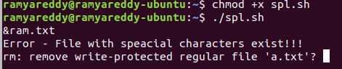

1. **Write a shell script to send an email stating "File Executed" whenever a particular file is executed.**

**email.sh**

#!/bin/sh

echo "This is the message body" ׀ mutt -a "email.txt" -s "subject of message" – sowmiselvam411@gmail.com

**Screenshot:**



׀